SIMATS ENGINEERING (SAVEETHA SCHOOL OF ENGINEERING)
Department of Computer Science and Engineering
CO3 ASSESSMENT TOOL 1 – Git & Docker Technical Assignment

Course Code: | CSA10 / CSA1063 | Course Title: | Software Engineering
CO Assessed: | CO3 | Assessment: | Assessment Tool 1 – Git & Docker Technical Assignment
Weightage: | 20% | Total Marks: | 25
CO3 Statement: | Build full-stack applications with an emphasis on containerization, version control, and collaborative development
Student Name: | S.PRATEEKSHA | Reg. No.: | 192572137
Date: | 17/08/2026 | Duration: | 60 minutes

Code of Conduct
I S.PRATEEKSHA-192572137 (Name / Reg No) certify that this submission is my original work and that I have adhered to the guidelines specified for this assessment. I understand that any violation of academic integrity rules will result in disciplinary action.
Signature of the Student:S.PRATEEKSHA

Rubrics for Calculation
Evaluation Criteria | Excellent (4 Marks) | Good (3 Marks) | Satisfactory (2 Marks) | Needs Improvement (1 Mark)
Problem Analysis & Project Design(20%) | Clearly explains the problem statement, objectives, requirements, expected outcomes, and well-organized project structure with proper justification. | Good analysis and project structure with minor omissions. | Basic analysis and repository structure with limited justification. | Incomplete or unclear analysis and project organization.
Git Repository & Branching Strategy(20%) | Repository initialized correctly with appropriate branching strategy, clear workflow, and proper repository organization. | Repository and branching strategy are mostly correct. | Basic Git setup with limited branching implementation. | Incorrect or incomplete Git repository and branching strategy.
Version Control Workflow & Commit History(10%) | Demonstrates meaningful commits, branching, merging, synchronization, conflict resolution, and professional commit messages with clear history. | Most Git operations demonstrated correctly with good commit history. | Limited Git workflow and commit practices. | Poor workflow and inadequate commit history.
Docker Implementation(20%) | Well-designed Docker environment, Dockerfile, and Docker Compose configuration with clear explanation of services, networking, volumes, and dependencies. | Functional Docker implementation with minor issues. | Basic Docker implementation with limited explanation. | Incomplete or incorrect Docker implementation.
Deployment, Testing & Results(15%) | Application successfully deployed and tested with appropriate screenshots and evidence of successful execution. | Deployment completed with minor issues. | Partial deployment and testing demonstrated. | Deployment unsuccessful or insufficient evidence.
Documentation, Challenges & Future Enhancements(15%) | Professional report (10–15 pages) with diagrams, screenshots, references, discussion of benefits, challenges, and future improvements. | Good documentation with minor omissions. | Basic documentation with limited discussion. | Poor documentation and insufficient analysis.

Criteria | Mark
System Requirement Analysis (30%) | /5
Selection of Software Architecture (25%) | /5
Architecture Diagram and Component Design (20%) | /5
Component Interaction and Quality Attribute Analysis (15%) | /5
Architectural Justification and Technical Presentation (10%) | /5
TOTAL | /25

Annexure A – Git & Docker Technical Assignment
Instructions to Students:
Each student has been assigned an individual problem statement. Based on the assigned problem statement, prepare a Git & Docker Technical Assignment by applying version control and containerization concepts. Your report should include appropriate diagrams, screenshots, commands, and explanations wherever applicable.

Assignment Questions
- Problem Analysis
  - Explain the assigned problem statement and identify the project objectives, functional requirements, and expected outcomes.
1.1 Problem Statement
Organizations need an efficient way to evaluate employee performance and analyze productivity. Traditional employee evaluation methods often depend on manual records, spreadsheets, and subjective observations. These approaches can be time-consuming, difficult to maintain, and may not provide sufficient analytical information for management.
The Employee Performance Evaluation and Productivity Analytics System is proposed as a software application that collects employee performance information, evaluates performance using measurable parameters, and generates productivity analytics. The system provides managers with a centralized platform to monitor employee performance and make data-driven decisions.
The system can store information such as employee details, attendance, task completion, performance scores, productivity metrics, and evaluation results.
1.2 Project Objectives
The major objectives are:
- To develop a centralized system for managing employee performance information.
- To evaluate employees using predefined performance parameters.
- To calculate productivity scores based on employee activities and completed tasks.
- To provide analytical reports and performance summaries.
- To help managers identify high-performing and low-performing areas.
- To reduce manual effort in employee performance evaluation.
- To provide a reliable and maintainable application using Git and Docker.

1.3 Functional Requirements
Requirement | Description
Employee Management | Add, update, delete and view employee information.
Task Management | Record assigned and completed tasks.
Performance Evaluation | Record and calculate employee performance scores.
Productivity Analysis | Calculate productivity based on measurable parameters.
Dashboard | Display performance and productivity statistics.
Report Generation | Generate employee performance summaries.
Search | Search employees using employee ID, name or department.
Authentication | Provide secure access for authorized users.
Database Management | Store employee and evaluation information.
1.4 Non-Functional Requirements
- Performance: The system should respond quickly to normal user requests.
- Security: Only authorized users should access employee information.
- Scalability: The application should support an increasing number of employees.
- Maintainability: The source code should be organized into independent modules.
- Portability: The application should run consistently across different environments.
- Availability: The application should be easily deployable using Docker.
- Usability: The interface should be simple and understandable.
1.5 Expected Outcomes
The expected outcomes are:
- Centralized employee performance data.
- Automated performance score calculation.
- Productivity analytics dashboard.
- Reduced manual evaluation effort.
- Better management decision-making.
- Reproducible deployment using Docker.
- Organized development and version control using Git.

- Project Structure Design
  - Design and explain the folder structure of your project repository.
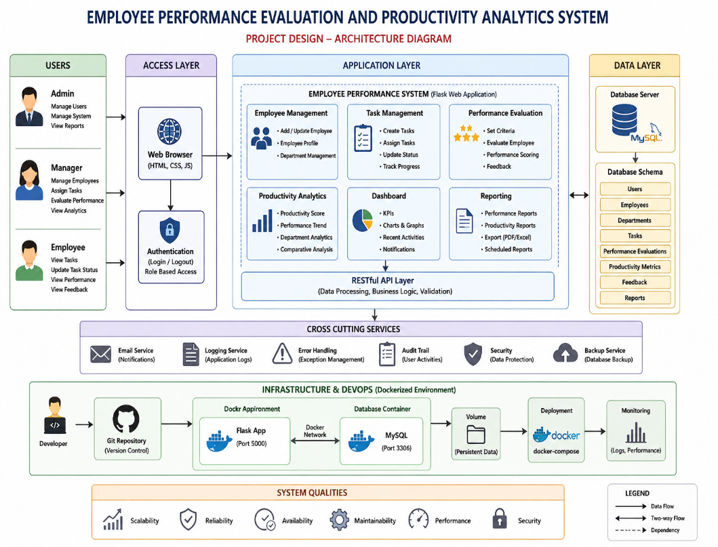
  - Justify the purpose of each major folder and file included in the repository.

The project repository is organized into separate folders so that each part of the Employee Performance Evaluation and Productivity Analytics System has a specific responsibility. This makes the project easier to develop, test, maintain, and deploy.
frontend/
Contains all user interface components of the system. It includes HTML pages, CSS stylesheets, JavaScript files, forms, employee pages, evaluation pages, and the productivity dashboard.
backend/
Contains the main application logic. It handles employee management, task management, performance evaluation, authentication, API requests, and communication with the database.
backend/models/
Contains the data models used by the system. Models can represent employees, departments, tasks, performance evaluations, productivity metrics, and feedback.
backend/routes/
Contains the different application routes and API endpoints. It manages requests related to employees, tasks, evaluations, analytics, and reports.
backend/services/
Contains the main business logic of the application. It performs operations such as calculating performance scores, productivity scores, employee rankings, and performance summaries.
database/
Contains database-related files. The database stores employee details, task information, evaluation scores, productivity records, and reports.
analytics/
Contains the productivity and performance analysis functions. It generates statistics, trends, comparisons, and analytical results that can be displayed on the dashboard.
tests/
Contains test cases used to verify that the different modules of the application work correctly.
config/
Contains configuration settings required by the application, such as database connection settings and application configuration.
docs/
Contains project documentation, architecture diagrams, workflow diagrams, and other technical documents.
Dockerfile
Contains instructions for creating the Docker image of the application. It defines the base image, dependencies, application files, exposed port, and startup command.
docker-compose.yml
Defines the services required by the project. In this system, it can manage the application container and MySQL database container together.
requirements.txt
Contains the Python libraries and dependencies required to run the backend application.
.gitignore
Specifies files and folders that should not be tracked by Git, such as virtual environments, temporary files, log files, and sensitive configuration files.
.dockerignore
Specifies files that should not be copied into the Docker image. This helps reduce the Docker image size.
.env
Contains environment-specific configuration such as database name, username, password, and application settings. Sensitive information should not be committed to the Git repository.
README.md
Provides complete information about the project, including its purpose, installation procedure, Git commands, Docker commands, testing procedure, and usage instructions.

- Git Repository Initialization
  - Create a Git repository for the project.
  - Explain the steps involved in repository initialization and describe the purpose of the essential Git files.
Git is used to track changes to the project source code and maintain different versions of the system.
3.1 Git Initialization Commands
Open the project folder in Command Prompt or terminal:
mkdir employee-performance-system
cd employee-performance-system
git init
git status
git add .
git commit -m "chore: initialize employee performance analytics project"
git branch -M main
The repository can then be connected to a remote Git hosting service:
git remote add origin <repository-url>
git push -u origin main
3.2 Purpose of Essential Git Files
.git directory
The .git directory is created automatically after:
git init
It contains Git's internal information, including commit history, branches, configuration and object data.
.gitignore
Example:
__pycache__/
*.pyc
.env
venv/
.vscode/
.idea/
*.log
It prevents unnecessary or sensitive files from being committed.
README.md
Contains:
- Project description
- Installation instructions
- Git workflow
- Docker commands
- Testing procedure
- Project screenshots

- Git Branching Strategy
  - Design a suitable branching strategy (e.g., Main, Development, Feature, Release, Hotfix).
  - Justify why the selected branching model is appropriate for the assigned project.
A structured branching strategy is used to support collaborative development.
4.1 Proposed Branches
main
│
└── develop
│
├── feature/employee-management
├── feature/performance-evaluation
├── feature/productivity-analytics
└── feature/dashboard
Additional branches:
release/v1.0
hotfix/login-security
4.2 Branch Description
Branch | Purpose
main | Contains stable production-ready code.
develop | Integrates completed features before release.
feature/* | Used for developing individual features.
release/* | Used for final testing and release preparation.
hotfix/* | Used to quickly fix critical production problems.
4.3 Why This Strategy Is Suitable
This project contains multiple independent modules such as employee management, performance evaluation, analytics and dashboard development.
Feature branches allow developers to work independently without affecting the stable application.
The develop branch acts as an integration area, while main contains stable versions.
Therefore, this branching model provides:
- Better collaboration.
- Reduced risk of breaking stable code.
- Easier testing.
- Organized feature development.
- Controlled software releases.
- Easier maintenance.

- Version Control Workflow
  - Demonstrate the Git workflow by performing meaningful commits, branch creation, merging, conflict resolution (if applicable), and repository synchronization.
  - Explain the purpose of each Git operation performed.

5.1 Creating Development Branch
git checkout -b develop
git push -u origin develop

5.2 Creating a Feature Branch
For employee management:
git checkout develop
git checkout -b feature/employee-management
After implementation:
git add .
git commit -m "feat: add employee management module"
Push the branch:
git push -u origin feature/employee-management

5.3 Merging a Feature
After testing:
git checkout develop
git pull origin develop
git merge feature/employee-management
git push origin develop

5.4 Developing Performance Evaluation
git checkout develop
git checkout -b feature/performance-evaluation

git add .
git commit -m "feat: implement employee performance evaluation"

git checkout develop
git merge feature/performance-evaluation
git push origin develop

5.5 Conflict Resolution
A conflict may occur when two branches modify the same section of a file.
Check conflicts:
git status
Git may show:
CONFLICT (content): Merge conflict in app/routes.py
Open the file and resolve the conflict markers:
<<<<<<< HEAD
current code
=======
incoming code
>>>>>>> feature/performance-evaluation
After selecting the correct code:
git add app/routes.py
git commit -m "fix: resolve merge conflict in performance routes"

5.6 Repository Synchronization
Before starting new work:
git pull origin develop
After completing work:
git push origin feature/employee-management
This ensures that local and remote repositories remain synchronized.

- Commit History Analysis
  - Present the commit history of the project.
  - Explain how commit messages follow good version control practices and contribute to project maintenance.
A good commit history should clearly describe what changed.
Example:
a81f42c feat: add employee management module
b7321de feat: implement performance evaluation
c92d841 feat: add productivity analytics
d45e621 feat: create management dashboard
e53a712 test: add employee analytics tests
f63c210 docker: add application Dockerfile
g82d315 docker: configure database service
h91a420 docs: update project README

6.1 Good Commit Message Practices
The project follows a meaningful commit convention:
feat: add productivity analytics
fix: correct employee score calculation
test: add performance evaluation tests
docs: update installation instructions
docker: configure application container
Meaningful commit messages are better than messages such as:
update
changes
final
new

6.2 Viewing Commit History
Use:
git log --oneline --graph --all
Example:
* a81f42c feat: add employee management
* b7321de feat: implement performance evaluation
* c92d841 feat: add productivity analytics
* d45e621 feat: create dashboard
* e53a712 test: add analytics tests
* f63c210 docker: add application Dockerfile
* g82d315 docker: configure database
A clear history helps developers understand how the application evolved and makes debugging easier.

- Docker Environment Design
  - Explain why Docker is suitable for the assigned project.
  - Identify the application components that require containerization.
Docker is suitable for this project because the Employee Performance Evaluation and Productivity Analytics System requires an application environment and database environment.
Without Docker, developers may have different versions of Python, database software and dependencies.
Docker packages the application and its dependencies into containers, providing a consistent execution environment.
7.1 Components Requiring Containerization
The proposed system contains:
- Web Application Container
  - Runs the Python Flask application.
  - Handles user requests.
  - Provides the dashboard and APIs.
- Database Container
  - Runs MySQL.
  - Stores employee, task and evaluation data.
- Optional Database Administration Tool
  - Can be added for database management during development.
7.2 Docker Architecture
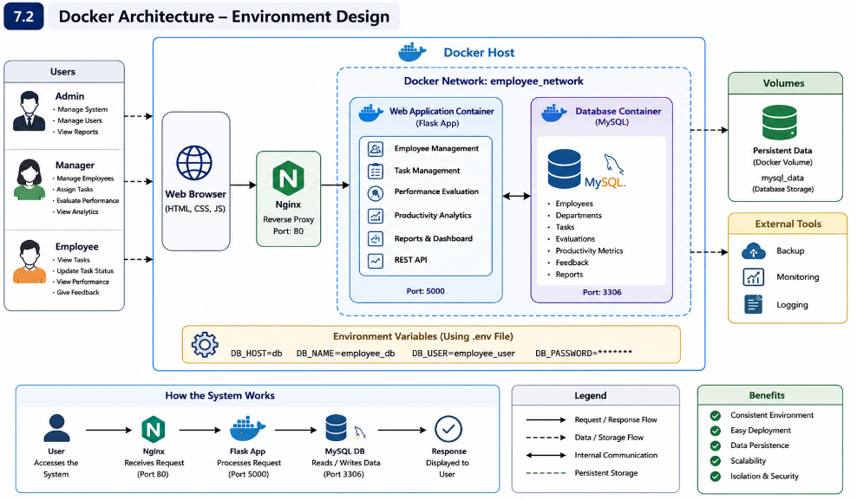

- Dockerfile Development
  - Design and explain the Dockerfile required to containerize the application.
  - Describe the purpose of each instruction used in the Dockerfile.
The Dockerfile defines how the application image is created.
8.1 Dockerfile
FROM python:3.12-slim
WORKDIR /app
COPY requirements.txt .
RUN pip install --no-cache-dir -r requirements.txt
COPY . .
EXPOSE 5000

CMD ["python", "run.py"]
8.2 Dockerfile Instruction Explanation
Instruction | Purpose
FROM | Selects the base Python image.
WORKDIR | Sets the working directory inside the container.
COPY requirements.txt | Copies dependency information.
RUN pip install | Installs required Python packages.
COPY . . | Copies application source code into the image.
EXPOSE 5000 | Documents the application port.
CMD | Starts the application when the container runs.
8.3 Example requirements.txt
Flask
Flask-SQLAlchemy
PyMySQL
python-dotenv
pandas
numpy
pytest

- Docker Compose Design
  - Develop a Docker Compose configuration for the project.
  - Explain the services, networking, volumes, environment variables, and dependencies used.
Docker Compose Design
Docker Compose is used to define and run multiple containers together.
The project uses two primary services:
- web
- db

9.1 docker-compose.yml
services:
web:
build: .
container_name: employee-performance-web
ports:
- "5000:5000"
environment:
DB_HOST: db
DB_NAME: employee_db
DB_USER: employee_user
DB_PASSWORD: employee_password
depends_on:
- db
networks:
- employee-network
db:
image: mysql:8.0
container_name: employee-performance-db
restart: unless-stopped
environment:
MYSQL_DATABASE: employee_db
MYSQL_USER: employee_user
MYSQL_PASSWORD: employee_password
MYSQL_ROOT_PASSWORD: root_password
volumes:
- mysql_data:/var/lib/mysql
networks:
- employee-network
volumes:
mysql_data:
networks:
employee-network:
driver: bridge
9.2 Services
Web Service
The web service builds the application image from the Dockerfile.
build: .
It exposes:
5000:5000
Therefore, the application can be accessed through:
http://localhost:5000
Database Service
The database uses:
image: mysql:8.0
It provides persistent storage for employee and performance information.
9.3 Networking
Both containers are connected to:
employee-network
The application accesses the database using the service name:
db
rather than:
localhost
This is important because localhost inside the web container refers to the web container itself.
9.4 Volumes
volumes:
- mysql_data:/var/lib/mysql
The volume ensures that database data remains available even if the database container is recreated.
9.5 Environment Variables
Environment variables store database configuration separately from application code.
Examples:
DB_HOST
DB_NAME
DB_USER
DB_PASSWORD
For a real deployment, sensitive passwords should be managed securely rather than committed to Git.
9.6 Dependencies
depends_on:
- db
This specifies that the web service depends on the database service being started.

10. Container Deployment and Testing
10.1 Build and Start Containers
Run:
docker compose up --build
Expected output will show containers being created and started.
Example:
employee-performance-web
employee-performance-db
10.2 Run in Background
docker compose up -d --build
10.3 Check Running Containers
docker compose ps
Expected result:
NAME STATUS
employee-performance-web Up
employee-performance-db Up

- Benefits of Git and Docker
  - Discuss how Git and Docker improve collaboration, version management, portability, deployment, scalability, and maintainability for your assigned project

11.1 Benefits of Git

Collaboration
Multiple developers can work on separate feature branches without directly modifying stable code.

Version Management
Git maintains a complete history of project changes.

Branching
Different modules can be developed independently.

Rollback
If a new change causes a problem, an earlier stable commit can be restored.

Code Review
Feature branches can be reviewed before merging into the main project.

11.2 Benefits of Docker

Portability
The application can run consistently on different computers.

Dependency Management
Python libraries and runtime requirements are packaged into the application environment.

Deployment
The complete application environment can be started using:
docker compose up

Scalability
Additional application containers can be deployed when the system grows.

Maintainability
Application and database environments are separated into services.

Reproducibility
Every developer can use the same container configuration.
.
- Challenges and Improvements
  - Identify the challenges encountered during implementation.
  - Suggest possible improvements and future enhancements for the Git workflow and Docker deployment.

12.1 Challenges

Git Merge Conflicts
Different developers may modify the same source-code sections, resulting in merge conflicts.
Solution: Frequently synchronize branches and communicate before modifying common files.

Dependency Compatibility
Different Python packages may require different versions.
Solution: Maintain a requirements.txt file and use a fixed Python base image.

Database Connectivity
The application may initially fail to connect to MySQL if the database is not ready.
Solution: Use Docker Compose service dependencies and implement database connection retry logic.

Data Persistence
Container data can be lost when containers are removed.
Solution: Use Docker volumes.

Environment Configuration
Passwords and database settings should not be hard-coded.
Solution: Use environment variables and secure secret-management mechanisms.

Large Docker Images
Installing unnecessary packages can increase image size.
Solution: Use lightweight base images and .dockerignore.

Expected Deliverables
- Technical report (10 pages)
- Git repository with complete commit history
- Source code of the assigned project
- Dockerfile
- Docker Compose file (docker-compose.yml)
- Screenshots of Git operations and Docker execution
- Architecture and workflow diagrams

